Chapter 1 Question 20 Michael Streyle

##   
## Call:  
## lm(formula = Minutes ~ Copier_serviced)  
##   
## Coefficients:  
## (Intercept) Copier_serviced   
## -0.5802 15.0352

## Analysis of Variance Table  
##   
## Response: Minutes  
## Df Sum Sq Mean Sq F value Pr(>F)   
## Copier_serviced 1 76960 76960 968.66 < 2.2e-16 ***  
## Residuals 43 3416 79   
## ---  
## Signif. codes: 0 '***' 0.001 '**' 0.01 '*' 0.05 '.' 0.1 ' ' 1

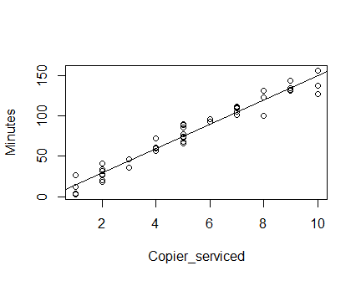

## (Intercept)   
## 74.59608

The intercept is -0.58 GPA units and the slope is 15.0352 GPA unit per ACT score increment.